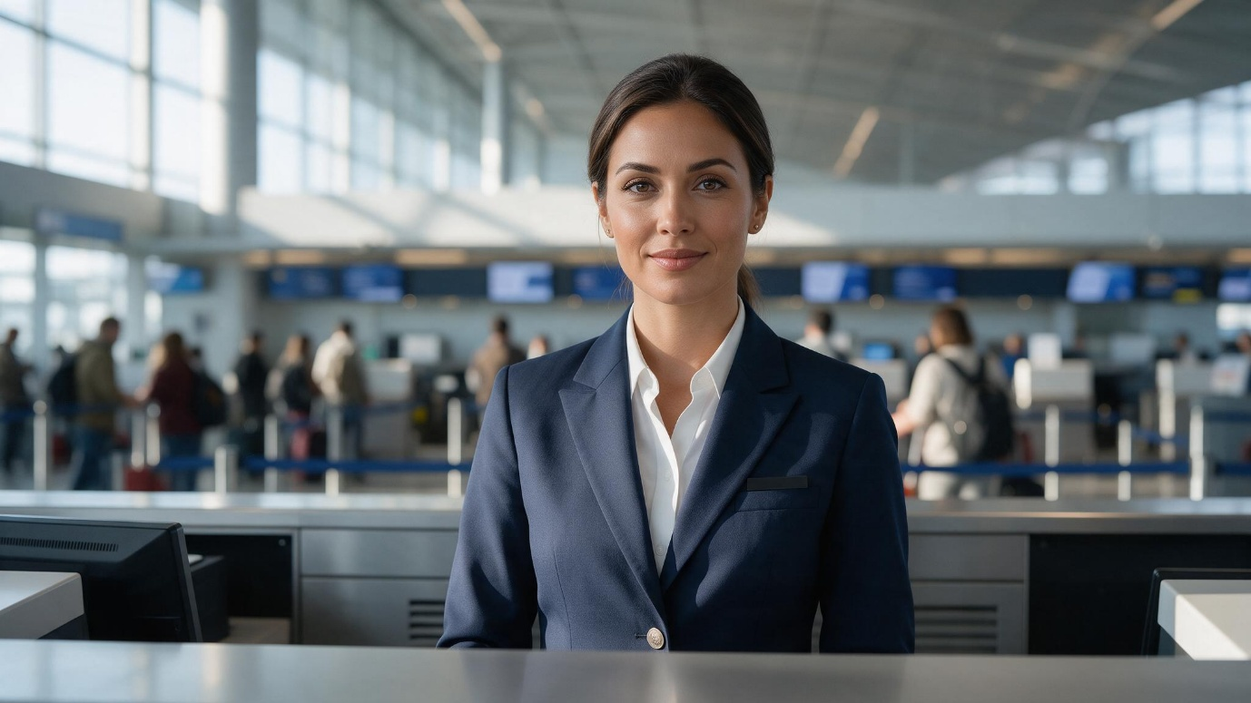
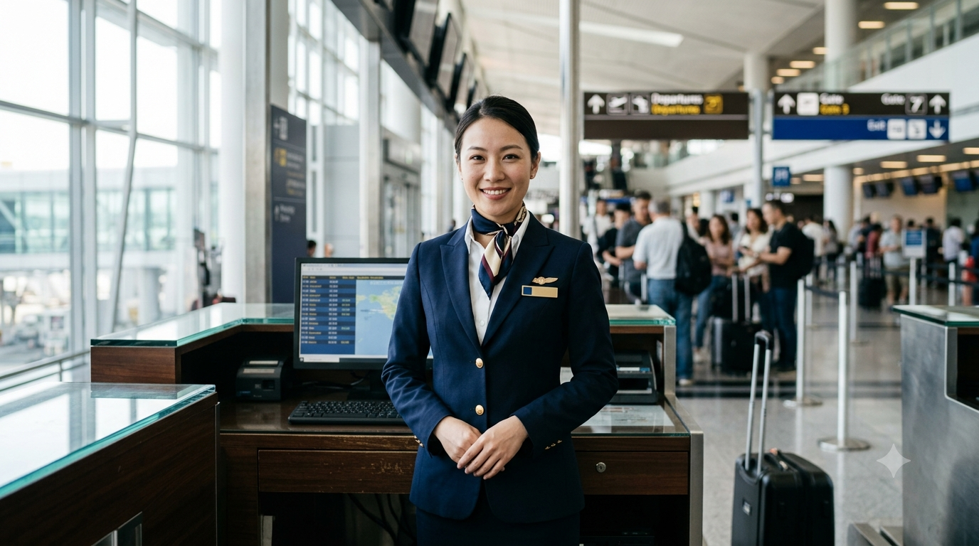
- Gemini
2. Perplexity
Evaluation Criterion | Tool 1 | Tool 2
Name of AI tool
Prompt followed correctly? | Yes | Yes
Human face appears realistic? | Yes | Yes
Skin texture appears natural? | Kinda | Yes
Eyes and hands are correct? | Yes | Yes
Airport environment is realistic? | Yes | Yes
Light comes from camera-left? | No | Yes
Uniform is professional? | Yes | Yes
Unwanted text or logos present? | No | No
Image looks AI-generated? Why? | No | No
Overall score out of 10 | 9 | 9.5

Answer each question in 2-3sentence
1. Which tool followed the prompt more accurately?
The first image followed the prompt more accurately because it clearly presents a professional airline staff member at a check-in counter in a realistic airport setting. The second image also fits the aviation context, but it adds more specific uniform and airport-signage details.
2. Which image appeared more realistic?
The first image appeared more realistic overall, especially because of its natural facial expression, skin texture, lighting, and background depth. The second image looks realistic too, but some background elements feel slightly AI-generated.
3. What differences did you observe in lighting?
The first image uses soft, natural daylight with a balanced and slightly cinematic look. The second image has brighter, more evenly distributed airport lighting, making it feel more like a professional promotional photograph.
4. Did either image contain distorted eyes, hands or facial features?
Neither image has major distortions in the eyes or facial features. The hands in the second image are also fairly natural, while the first image does not show the hands clearly enough to identify any distortion.
5. Which image would you use on an airline’s website?
I would use the first image because it has a clean, professional and premium appearance that suits an airline website. Its composition also keeps the staff member as the clear focus while still showing the airport environment.
6. What is the “visual accent” of each model?
The first model’s visual accent is professional, calm and corporate, with the navy suit and neutral airport setting. The second model’s visual accent is friendly, approachable and service-oriented, with the brighter expression, scarf and detailed airline-style uniform.


Part B
1.DeepAI




2.Krea

Question | Observation
Did the lighting direction change? | YES
Was camera-left followed correctly? | YES
Was camera-right followed correctly? | YES
Did the background remain consistent? | YES
Did the person’s appearance change? | YES
Which instruction was ignored, if any? | NO

